

# Community Recycling Ambassadors media kit

## About the Community Recycling Ambassadors program

To help residents take action for the environment, Hennepin County offers a Community Recycling Ambassador program. During a six-week course, Community Recycling Ambassador volunteers learn about waste prevention, recycling, and composting from industry experts. They then commit to volunteering 30 hours to inspire others in their communities to reduce waste, recycle more, and compost. Hennepin County is holding two rounds of the Community Recycling Ambassador trainings in 2023, one in the spring and one in the summer. See below for class dates and application details.

## Help spread the word

Please share the promotional messaging with the communities you work with. You can download campaign assets below.

* Use the sample newsletter article to share on your organization’s website or in your newsletters. These are editable so you can customize the length or message.
* Use the sample social media posts to share through your social media channels. These are editable so you can customize the message and website.
* Follow and reshare messages posted on the Hennepin County Environment and Energy social media channels: [Hennepin Environment on Facebook](https://www.facebook.com/HennepinEnvironment/), [Hennepin Environment on Instagram](https://www.instagram.com/hennepinenvironment/), and [@hennepinenviro on Twitter](https://twitter.com/HennepinEnviro)
* Share the information and resources available at [hennepin.us/recycling-ambassadors](https://www.hennepin.us/recycling-ambassadors)

# Program information

## We have a new name: Community Recycling Ambassadors

The Master Recycler/Composter program is rebranding as Community Recycling Ambassadors. The county decided to change the name of this program to help make it more inclusive and to better reflect the role these volunteers play in our community.

The word “master” has negative associations with plantation slavery in the U.S. We are moving away from its use because the county is committed to confronting racism, creating systems that build equity, and creating a future where all residents thrive. The program name “Community Recycling Ambassadors” better reflects Hennepin County’s efforts to reduce racial disparities and serve all residents, in all areas, including waste reduction and recycling.

Staff are working to update all webpages and resources with the new name. This will take some time, so you may see both the new and old name for a while. Program operations and classes will keep the same format. Thank you for your patience as we implement this rebrand.

## Upcoming trainings

The summer 2023 class will be held every Thursday from June 15 – July 27 (no class on July 6), from noon to 2 p.m. The class will take place virtually via Zoom.

The application for the summer class will open on Monday, May 22 and close on Monday, June 5. [Sign up to be notified about future Community Recycling Ambassador courses.](https://public.govdelivery.com/accounts/MNHENNE/subscriber/new?topic_id=MNHENNE_920)

Before applying, please ensure that you meet the following requirements:

* You are 18 years of age or older
* You live and/or work within Hennepin County
* You are available for all six class sessions
* You can commit to 30 hours of volunteering after the class completes
* You have access to internet and a computer or similar device to attend class virtually

## Contact

For more information about the Community Recycling Ambassador program, contact Kaitlin Keller, Waste Reduction and Recycling Specialist, at [kaitlin.keller@hennepin.us](mailto:kaitlin.keller@hennepin.us).

# Promotional resources

Use the sample newsletter article and social media posts below to promote the program.

## Become a Community Recycling Ambassador

If you are looking for ways to volunteer in your community, consider becoming a Hennepin County Community Recycling Ambassador!

The summer 2023 class will be held every Thursday from June 15 – July 27 (no class on July 6), from noon to 2 p.m. The class will take place virtually via Zoom.

The application for the summer class will open on Monday, May 22 and close on Monday, June 5. Check the webpage for details and add your email to be notified of upcoming classes: [hennepin.us/recycling-ambassadors](https://www.hennepin.us/recycling-ambassadors)

Community Recycling Ambassadors are trained on waste prevention, recycling and composting, and effective communication skills through a six-week course, with one class each week, taught by industry experts and community leaders. This training program is free to participants.

Once training is complete, participants commit to 30 hours of volunteering putting their skills to work on projects and activities that minimize waste and provide waste reduction, recycling and composting education.

Community Recycling Ambassadors are friendly sources of information on waste prevention, recycling, and composting. Learn more about the program here: [hennepin.us/recycling-ambassadors](https://www.hennepin.us/recycling-ambassadors)

# Social media posts

To use images and graphics: right click on image and select Save as Picture.

## Post 1

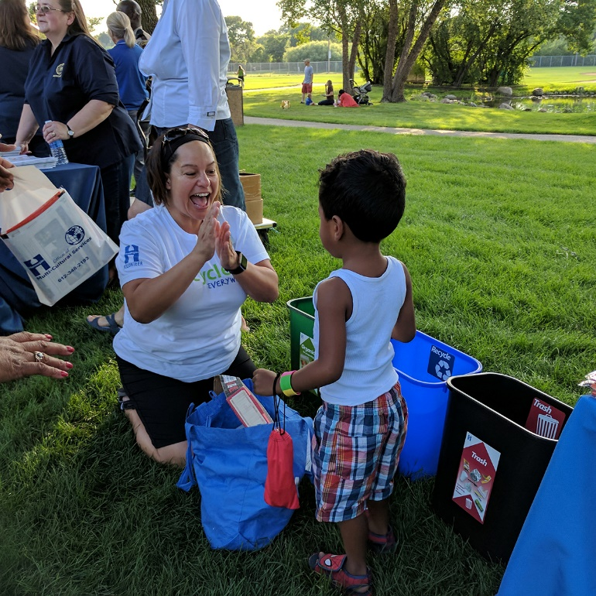**Facebook:** If you are looking for ways to volunteer in your community, consider becoming a Community Recycling Ambassador! Community Recycling Ambassadors are friendly sources of information on waste prevention, recycling, and composting. The summer Community Recycling Ambassador class will be held every Thursday from June 15 – July 27 (no class on July 6), from noon to 2 p.m. The class will take place virtually via Zoom. The application for the summer class will open on May 22 – sign up to be notified when the application is open: [hennepin.us/recycling-ambassadors](https://www.hennepin.us/recycling-ambassadors)

**Twitter:** If you are looking for ways to volunteer in your community, consider becoming a Community Recycling Ambassador! The application for the summer class will open on May 22. Sign up to be notified: [hennepin.us/recycling-ambassadors](https://www.hennepin.us/recycling-ambassadors)

## Woman and man looking at plastic container at outdoor event.Post 2

**Facebook:** Community Recycling Ambassadors are friendly sources of information on waste prevention, recycling, and composting and volunteer by putting their skills to work on projects and activities that minimize waste and provide waste reduction, recycling and composting education. The application for the summer class will open on May 22 – sign up to be notified when the application is open: [hennepin.us/recycling-ambassadors](https://www.hennepin.us/recycling-ambassadors)

**Twitter:** Community Recycling Ambassadors are friendly sources of information on waste prevention, recycling, and composting. The application for the spring class will open on May 22. Sign up to be notified: [hennepin.us/recycling-ambassadors](https://www.hennepin.us/recycling-ambassadors)