

Community zero waste grants media kit

About the grants
Community zero waste grants provide funding to community-based organizations to develop and lead waste prevention and diversion projects. This grant program embraces community-rooted projects, encompassing innovative solutions to reach zero waste in communities that are historically underserved. This grant will support place-based practices that provide benefits and long-term solutions to improve recycling and organics recovery from waste.
Applications will be accepted until Wednesday, December 4, 2024 at 2 p.m.
Grant information can be accessed here: hennepin.us/community-zero-waste-grants. Use the article, social media posts, and images below to help promote the grants.

Community zero waste grants
Examples of projects could include community-led swaps, repair clinics, special material collections, and recycling or organics drop-off sites that address waste programming gaps or culturally specific needs. Applicants may apply for up to $100,000 per year for up to 3 years to implement projects that advance the county’s zero-waste goals. There is no minimum grant award.

Review the 2024 community zero waste grant guidelines (PDF) and grant flyer (PDF) to learn more.

Apply
- Review the 2024 community zero waste grant guidelines (PDF).
- Apply through the Hennepin County Supplier Portal.

Contact
If you have questions about grants, contact the community zero waste grant coordinator, Didier Bolanos Gonzalez at Didier.BolanosGonzalez@hennepin.us or 612-919-3776.

Sample newsletter article
Share the sample newsletter article on your organization’s website or in your newsletters.

Grants are available for community-based waste prevention projects
Community zero waste grants provide funding to community-based organizations to develop and lead waste prevention and diversion projects.
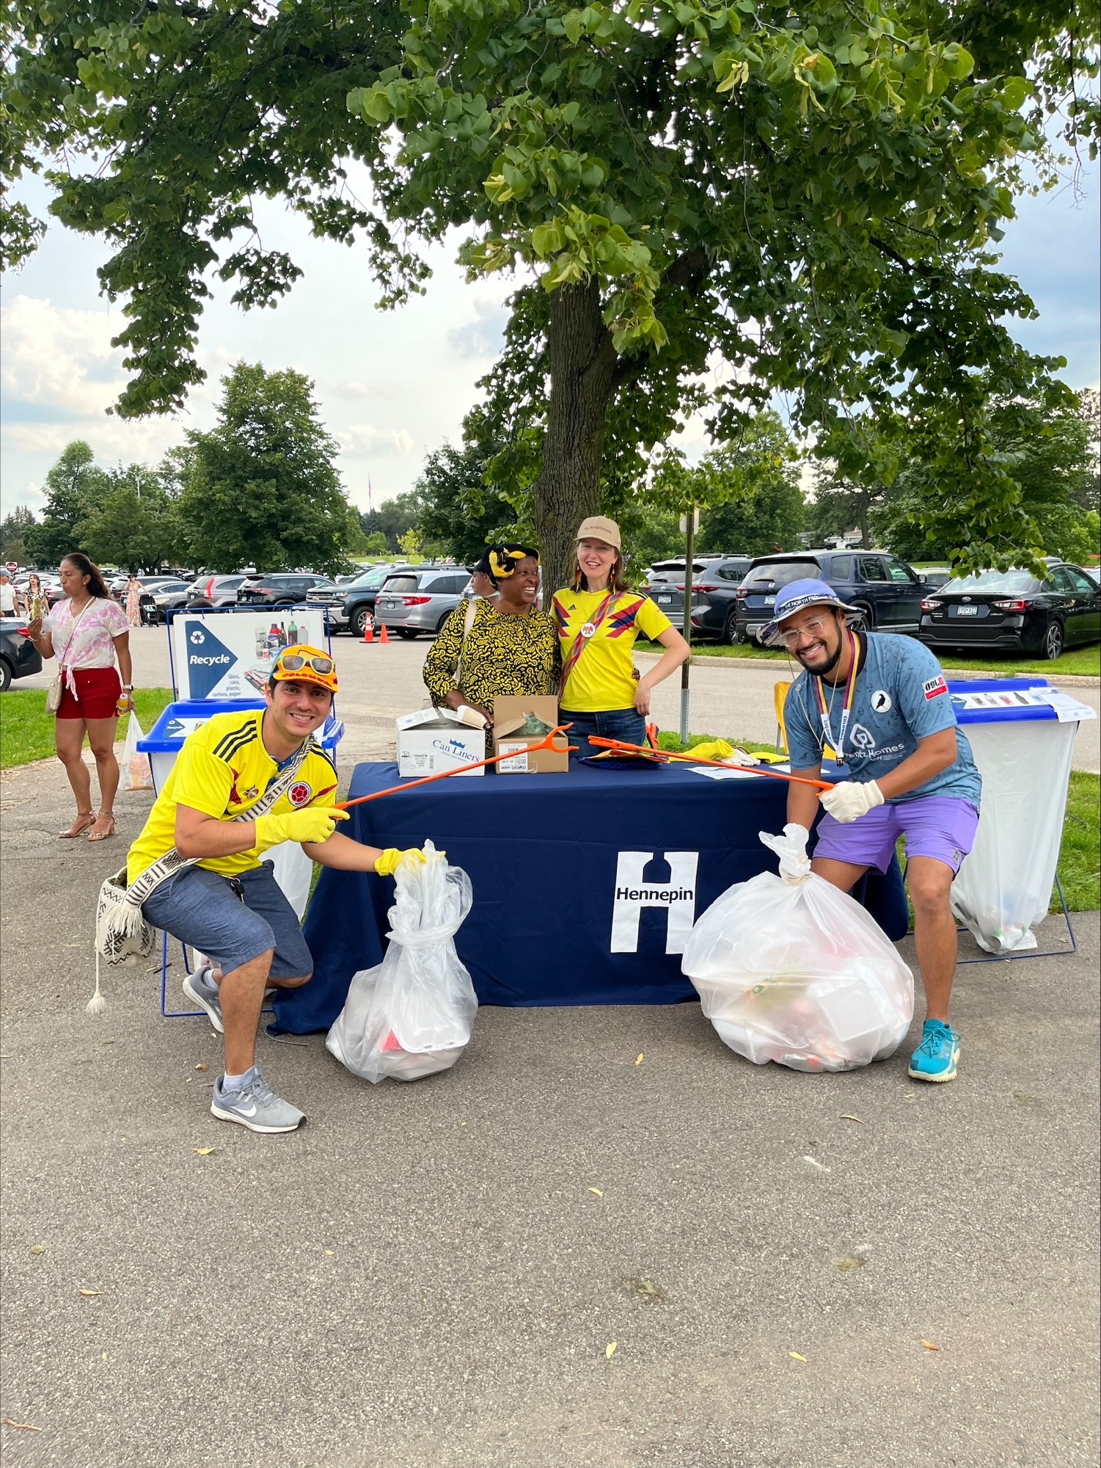
Examples of projects could include community-led swaps, repair clinics, special material collections, and recycling or organics drop-off sites that address waste programming gaps or culturally specific needs. Applicants may apply for up to $100,000 per year for up to 3 years to implement projects that advance the county’s zero-waste goals. There is no minimum grant award. Review the grant flyer (PDF) and the 2024 community zero waste grant guidelines (PDF) to learn more.
Applications are due on Wednesday, December 4 at 2 p.m.

Eligible applicants include:
- Community-based organizations located in Hennepin County that are registered with the Minnesota Secretary of State.
- Non-profit organizations that demonstrate community partnership and aim to expand zero-waste capacities in underserved areas of Hennepin County.
If you have questions about grants, contact the community zero waste grant coordinator, Didier Bolanos Gonzalez at Didier.BolanosGonzalez@hennepin.us or visit the community zero waste grant webpage.

Social media posts
Share these posts through your social media channels.

Facebook
Community zero waste grants provide funding to community-based organizations to develop and lead waste prevention and diversion projects. Examples of projects could include community-led swaps, repair clinics, special material collections, and recycling or organics drop-off sites that address waste programming gaps or culturally specific needs. Applicants may apply for up to $100,000 per year for up to 3 years to implement projects that advance the county’s zero-waste goals. There is no minimum grant award. Applications are due on Wednesday, December 4 at 2 p.m. Learn more and apply: hennepin.us/community-zero-waste-grants

Twitter/X
Community zero waste grants provide funding to community-based organizations to develop and lead waste prevention and diversion projects. Applications are due on Wednesday, December 4, 2024. Learn more and apply: hennepin.us/community-zero-waste-grants #CommunityZeroWaste #ZeroWasteGrant #ZeroWaste

Instagram
Community zero waste grants provide funding to community-based organizations to develop and lead waste prevention and diversion projects. Examples of projects could include community-led swaps, repair clinics, special material collections, and recycling or organics drop-off sites that address waste programming gaps or culturally specific needs. Applicants may apply for up to $100,000 per year for up to 3 years to implement projects that advance the county’s zero-waste goals. There is no minimum grant award. Applications are due on Wednesday, December 4, 2024. Learn more and apply at the link in our bio. #CommunityZeroWaste #ZeroWasteGrant #ZeroWaste

Nextdoor
Community zero waste grants provide funding to community-based organizations to develop and lead waste prevention and diversion projects. Examples of projects could include community-led swaps, repair clinics, special material collections, and recycling or organics drop-off sites that address waste programming gaps or culturally specific needs. Applicants may apply for up to $100,000 per year for up to 3 years to implement projects that advance the county’s zero-waste goals. There is no minimum grant award. Applications are due on Wednesday, December 4, 2024. Learn more and apply: hennepin.us/community-zero-waste-grants

Photos
To use photos and graphics, right click the photo and choose Save as Picture.
